## Code Review of F3

Code Review Done By: Nirav Patel (40081268)

Function Developed By: Prashant Patel

**F3 : Sinh(x)**

1. For the method defined in SinhFunction.java, double epowerx(double x)

This method and/or other methods can be static if they do not require to hold the state of the object or more than 2 operations are not being performed simultaneously. According to Prof lecture 7, Page 70 (Chapter 14).

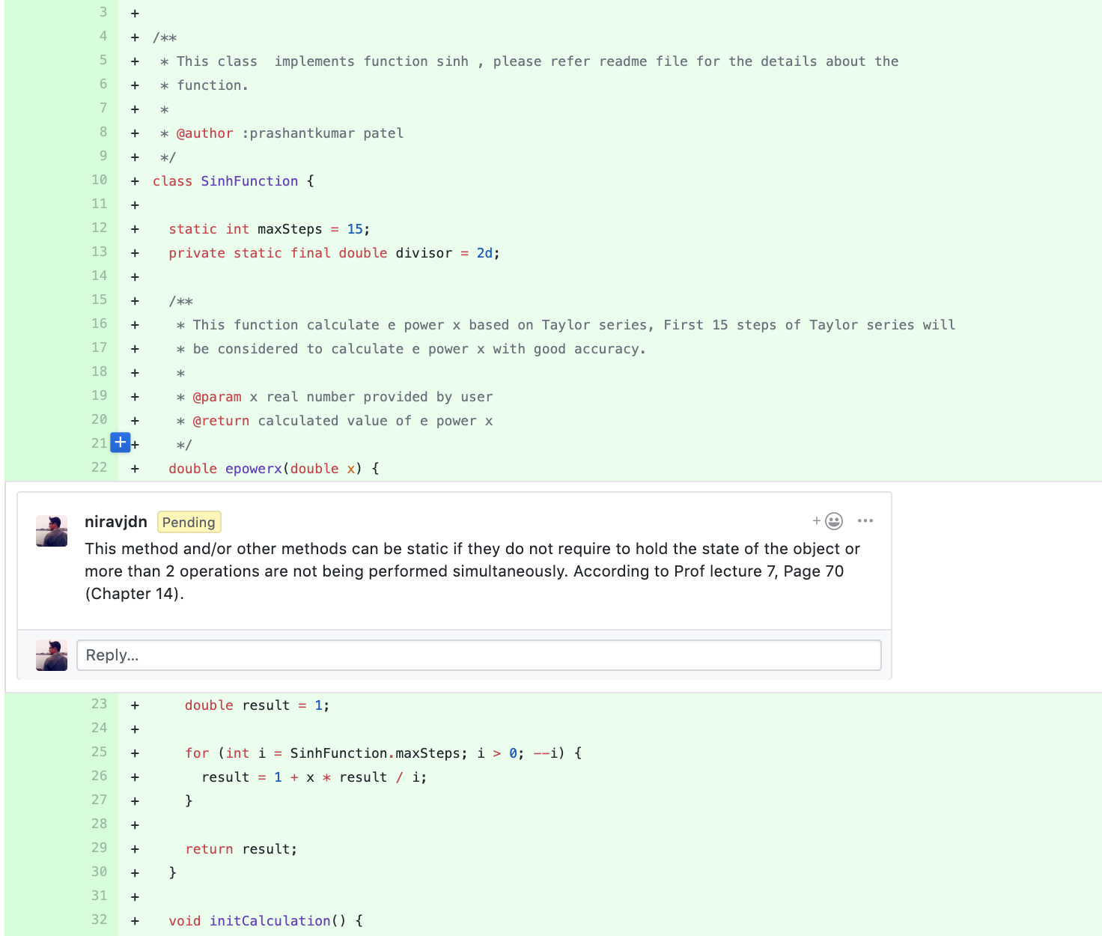

2. If Javadoc is meant to be created, then it's missed here and at some other places.

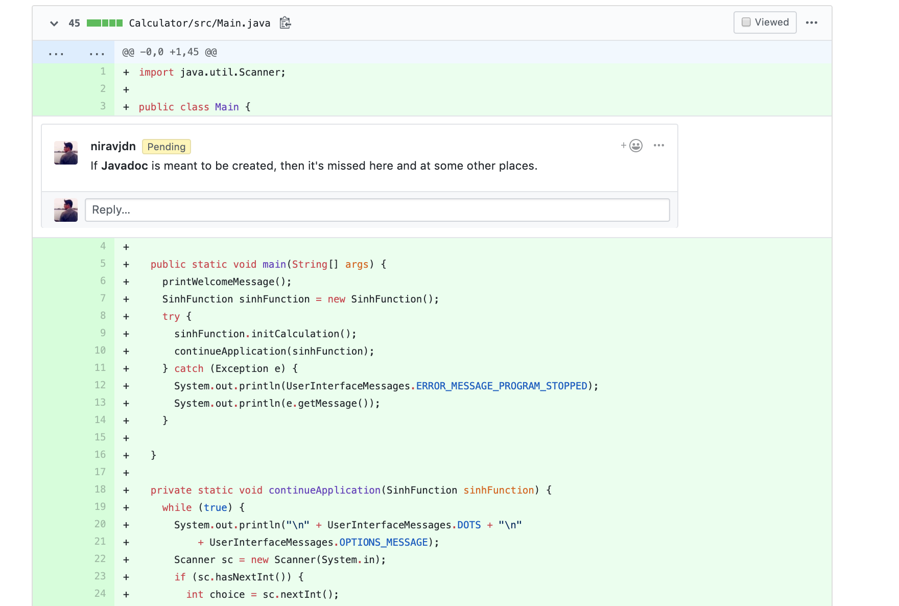

3. For the validatonUtils.java, it validates whether the input and output is in valid range or not, it checks for the different condition and prints the same message, which can be combined in single if condition by making use of logical OR (||) condition.

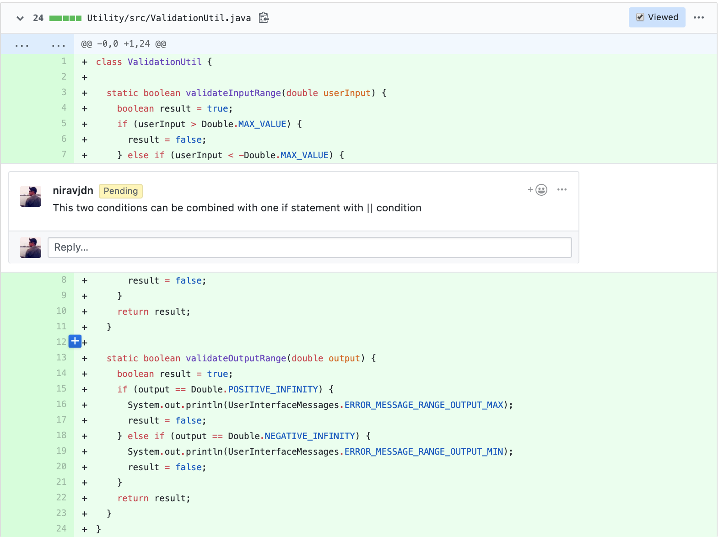

4. For the test case, proper import can help in not writing the respective package name while using class belonging to that package name. So instead of @org Junit.Test, it can be written as @Test only.

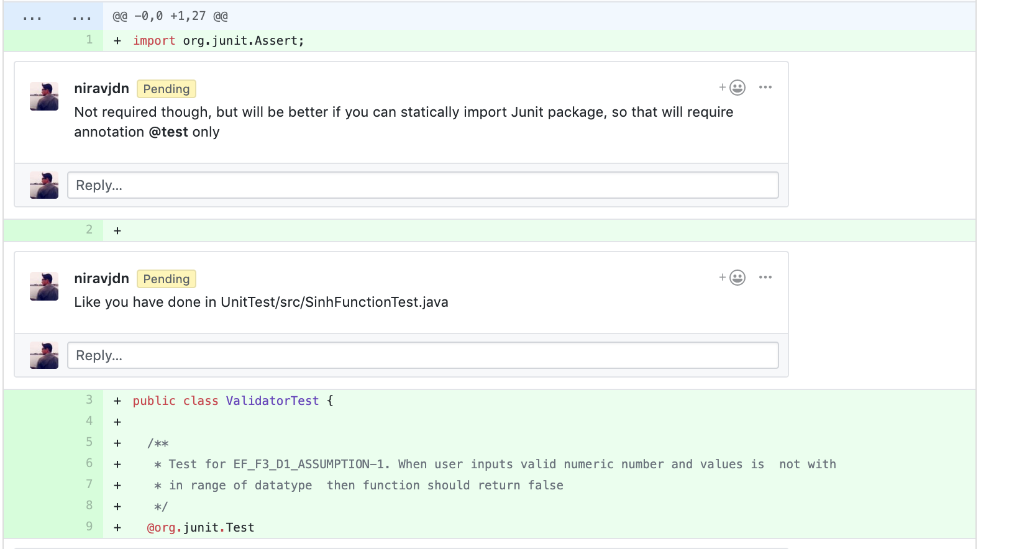

5. Not necessary, but as a standard practice of Junit test cases, Assert class from junit package can be imported as static. So it requires just the use of assertEquals instead of Assert.assertEquals().